Noise Monitoring Form

Operating Business |  | Development /  COINS No.
Monitoring Equipment Details |  | Calibration Details

Date |  | Site Activities
Weather |  | Temperature
Wind Direction |  | Wind Speed

Time | Location | T (Mins) | Average level dB(a) threshold ~70 | Actions / comments

Completed by |  | Signature

MONITORING PROCEDURE

Noise monitoring must include both on-site and off-site checks. Agree the monitoring locations with your Group Health, Safety & Environment Advisor. This should be formalised into a Noise Monitoring Plan (NMP), see example below:

On-site checks must be carried out along the site perimeter. Off-site checks must be carried out at nearby receptors e.g. residential properties, schools etc. The noise monitoring device must be either Class 1 or Class 2 level standard and must be regularly calibrated.

Complete noise monitoring daily for all locations identified on your NMP. Complete a separate form each day.
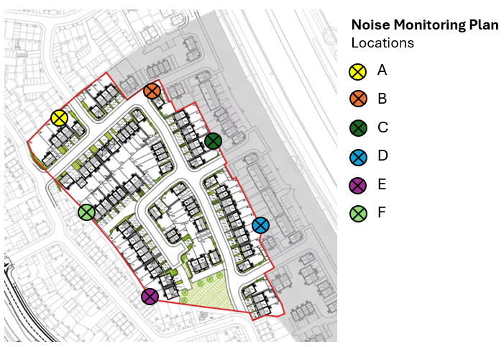
- Site activities – note the relevant construction activities being undertaken on site for the day.
- Weather – note the weather conditions of the previous 12 hours i.e. dry and sunny, intervals of heavy rain. Record the temperature, wind speed and direction, this can be taken from the Met Office or https://xcweather.co.uk/.
- Time – record the time of the monitoring.
- Location – record the location e.g. A, B, C or 1, 2, 3 (refer to your NMP) or outside no. 1 Main Street etc.
- T (Mins) – record the time spent undertaking the check in mins.
- Average (dBa) – to measure this you require a suitably calibrated noise monitoring device. Note anything above 70 dB(a) may be considered an environmental concern. Report any incidents or concerns to your Group HS&E Advisor immediately.
- Actions / comments – record any findings associated with the monitoring i.e. dumper trucks / plant working in an area, road traffic, noisy train passing etc.

