Dust Monitoring Form

Operating Business |  | Development/ COINS No.

Date |  | Site Activities
Weather |  | Temperature
Wind Direction |  | Wind Speed

Dust monitoring must include both on-site and off-site checks. On-site checks must be carried out along the site perimeter. Off-site checks must be carried out at receptors e.g. residential properties. If complaints are received, then it is highly likely static monitoring devices will be required to be installed; if so, speak with your Group Health, Safety & Environmental Advisor.

Time | Location | T (Mins) | Visual assessment / observations | Actions / comments

Completed by |  | Signature

MONITORING PROCEDURE
Agree the monitoring locations with your Group Health, Safety & Environment Advisor. This should be formalised into a Dust Monitoring Plan (DMP), see example below:
Complete dust monitoring daily for all locations identified on your DMP. Complete a separate form each day.
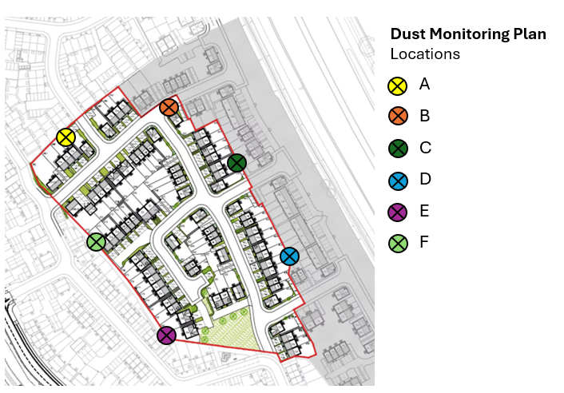
- Site activities – note the relevant construction activities being undertaken on site for the day.
- Weather – note the weather conditions of the previous 12 hours i.e. dry and sunny, intervals of heavy rain. Record the temperature, wind speed and direction, this can be taken from the Met Office or https://xcweather.co.uk/.
- Time – record the time of the monitoring.
- Location – record the location e.g. A, B, C or 1, 2, 3 (refer to your DMP) or outside no. 1 Main Street etc.
- T (Mins) – record the time spent undertaking the check in mins.
- Visual assessment / observations – record any findings i.e. dust blow, dust deposits on surfaces such as street furniture, vehicles etc. Record both good and bad observations.
- Actions / comments – Record any actions / comments associated with the monitoring. Report any incidents or concerns to your Group HS&E Advisor immediately.

