This template is intended as a guide and is not exhaustive.

This Surface Water Management Plan template should only be completed by a competent person and in agreement with your GHSEA.

The priority should always be to appoint a suitably qualified external consultant to produce the Plan.



Surface Water Management Plan (SWMP)



INSERT PROJECT NAME INSERT PROJECT NUMBER

**Revision Control Sheet**

|  |  |  |  |
| --- | --- | --- | --- |
| **Revision Number:** | **Description of changes made:** | **Updated by:** | **Date of Update:** |
|  |  |  |  |
|  |  |  |  |
|  |  |  |  |
|  |  |  |  |
|  |  |  |  |
|  |  |  |  |
|  |  |  |  |
|  |  |  |  |
|  |  |  |  |
|  |  |  |  |

**Note: the SWMP is to be reviewed at least every three months**

**Contents**

1.0 Introduction 4

1.1 Project Overview 4

2.0 Planning Phase Action 5

3.0 Operational Phase Action 5

3.1 Potential Sources of Contamination 5

3.2 Potential Receptors 5

4.0 Pollution Control Measures 5

4.1 Drain Protection 6

4.2 Surface Water 6

4.3 Controlling Run-off 7

4.4 Treatment Measures Identified 8

4.5 Permit to Pump 8

5.0 Environmental Awareness & Training 8

5.1 Specific Roles 9

6.0 Communication 9

7.0 On-Site Monitoring Regime 9

7.1 Visual Inspection 10

7.2 Assessing Turbidity 10

7.3 Inspections 11

8.0 Emergency & Incident Preparedness 11

9.0 Environmental Observations & Incidents 11

# 

# 1.0 Introduction

This Surface Water Management Plan (SWMP) has been prepared for **INSERT PROJECT NAME** in accordance with the Persimmon Environmental Management System (EMS). It identifies specific control methods and procedures which will be adopted to minimise the risk posed to surface waters.

The SWMP will be subject to further development in response to changing site constraints and as the project progresses. The project team in consultation with the local Group Health, Safety & Environmental Advisor, must make all amendments to the SWMP.

# 1.1 Project Overview

The project consists of the construction of **INSERT PROJECT OVERVIEW**. **Location Map**

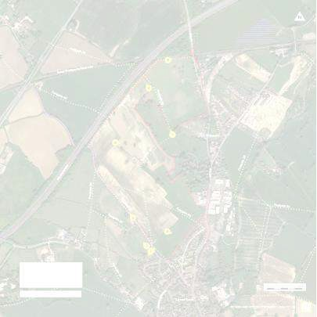

INSERT MAP

# 2.0 Planning Phase Action

Prior to the discharge of any water to site a visual inspection will be undertaken. If further testing is required water samples will be taken and turbidity assessed (NTU). Dependent on previous use for the site, contamination may also be present; this could be in the form of hydrocarbons, metals etc.

If it is determined that contamination is present, no water can be discharged directly to surface or groundwater.

# Operational Phase Action

# Potential Sources of Contamination

Almost any solid, liquid or gaseous substance entering surface water or groundwater could cause pollution. Potential sources identified on this project includes:

* + - Chemicals
    - Concrete wash
    - Fuels and oils
    - Road sweeper waste
    - Surface water run-off containing sediment (gravel, sand, silt, clay)
    - Sewage effluent
    - Waste products

# Potential Receptors

The following potential receptors have been identified:

* + - Insert name of watercourse(s) etc.
    - Insert name of watercourse(s) etc.
    - Insert name of watercourse(s) etc.

# Pollution Control Measures

Persimmon will consider pollution control measures throughout the planning and implementation of the project.

# Drain Protection

To be amended, as necessary

Protection will be provided for all surface water drains, manholes and or gullies (whether existing or newly installed). Protection is to be installed in the form of gully guard bags with geotextile terram on top, as shown below.

Protection measures will be regularly inspected and maintained to ensure ongoing performance. A formal inspection and maintenance schedule will be in place prior to start on site (to be agreed with relevant subcontractors) and will form part of this Plan.

# Surface Water

Surface water management for the will primarily use passive silt control options. Measures to be implemented on **INSERT PROJECT NAME** include:

* + - Adoption of good working practices (e.g. clean haul roads and site access points)
    - installation of drainage/soakaways
    - dewatering over vegetated areas
    - filtration (via sediment sock)
    - silt capture channels
    - natural settlement

Only when this avenue has been exhausted will active controls such as the use of flocculants and, or coagulants be introduced as a water treatment recommendation. Example passive measures to be used:

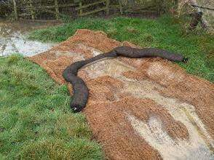

**Silt capture channel (i)**

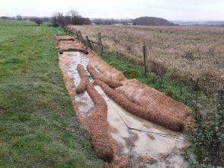

**Silt capture channel (ii)**

# Controlling Run-off

The site will protect any vulnerable areas which could lead to a water pollution. This will be in the form of bunds, v-ditches and/or silt fencing. Water from neighbouring sites will be intercepted and prevented from entering site through the construction of ditches and/or soil bunds.

V-ditches and filter drains will be installed where necessary to enable the controlled movement of surface water on site. Rock checks and/or hay bales will be used in ditches to help slow the flow, naturally aiding the settlement of sediment. Sediment mats will be laid into the channels to aid capture of any sediment.

Where necessary, surface water will be diverted to attenuation basin(s) to retain water in an undisturbed state long enough for suspended solids to settle out. The clean water then either flows out at the discharge point or is pumped out.

Additional ditches should be cut as the project progresses to intercept surface water run-off from any areas with exposed soils and haul roads or to prevent uncontrolled run-off from site. They will be positioned so that they can remain undisturbed for as long as the work programme requires.

# Treatment Measures Identified

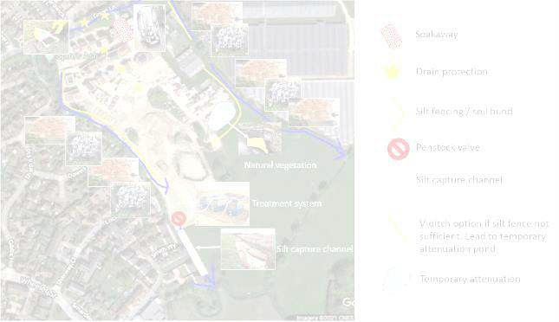

**INSERT PLAN SHOWING LOCATIONS OF TREATMENT METHODS**

# Permit to Pump

Prior to the discharge and/or pumping of any water a ‘Permit to Pump’ will be issued by Site Management (**EMS-FOR-011 – Permit to Pump**). This is in addition to any permits or licences required by the Regulator.

A permit to pump must be renewed if the operation changes or the pumping is longer than one week in duration.

# Environmental Awareness & Training

The project will require specific roles, toolbox talks and training, dependent on the works occurring on site.

All key persons must be identified alongside their role and responsibility. A nominated person shall have responsibilities that includes but are not limited to:

* + - All project operatives and supervisory staff will receive a site-specific induction that covers environmental issues associated with their roles and responsibilities
    - More detailed training, such as that required for pollution control measures and waste management plans, will be given to staff as required.
    - Training on specific environmental topics will be given by suitably qualified personnel where required.
    - Group Health, Safety & Environment Advisors and/or Site Supervisors will give toolbox talks to operatives on key issues such as silt control, water pollution prevention, and spill response; keeping a record of all operatives that undertake the induction and toolbox talks.
    - Details of task specific Environmental Operational Controls including any permit conditions and detailed methodologies shall be included in RAMS
    - Display posters such as Silt Control and Spill Response
    - Ensure permits to pump are in place

# Specific Roles

The Site Manager will act as lead in respect of surface water management, with support from relevant subcontractors.

# Communication

The Site Management team are responsible for communicating the requirements of the SWMP to sub-contractors.

Methods of communication include:

* + - Induction
    - Toolbox Talks
    - Subcontractor meetings
    - HS&E Noticeboards

If a pollution event is deemed to have occurred (as per EMS STD – Environmental Incident Reporting), then the Regulator will be notified of the event, and remedial measures undertaken.

Regulator contact details: delete/keep below as necessary

* **Environment Agency** – 0800 80 70 60
* **Natural Resources Wales** - 0300 065 3000
* **Scottish Environment Protection Agency** - 0800 80 70 60

# On-Site Monitoring Regime

In order to ensure that the mitigation and treatment process is working correctly, self-monitoring will be undertaken by trained site personnel on a daily basis. Increased inspections may be implemented following a heavy rainfall event.

The monitoring should include as a minimum; visual inspection, and where required, turbidity (NTU) assessment using a calibrated NTU meter.

# Visual Inspection

Daily inspections of the water treatment setup and receiving watercourse will be undertaken by trained personnel. Any defects or observations (e.g. silty water leaving site) will be reported immediately to the Site Management.

# Assessing Turbidity

**Baseline assessment** – daily monitoring of the INSERT NAME OF WATERCOURSE, for a two week period, will be undertaken prior to the start of works. Samples will be taken by trained personnel using a calibrated NTU meter to assess the turbidity of the watercourse. Results are shown in the table below.

|  |  |  |  |
| --- | --- | --- | --- |
| **Name of watercourse** | **Date** | **Weather** | **Turbidity (NTU)** |
|  |  |  |  |
|  |  |  |  |
|  |  |  |  |
|  |  |  |  |
|  |  |  |  |
|  |  |  |  |
|  |  |  |  |
|  |  |  |  |
|  |  |  |  |
|  |  |  |  |
| **Average Turbidity** |  |  |  |

**Assessment prior to discharge** - where necessary, trained personnel will undertake water sampling to assess the turbidity of water being discharged from site using a calibrated NTU meter.

Should an elevated result be encountered no discharge will take place, or in the event that the discharge is ongoing, this will be ceased until appropriate measures have been put in place to remove the source of pollution.

If turbidity is considered too high water will not be discharged. All monitoring will be recorded on **EMS-FOR-010 – Water Discharge Monitoring Form** and photographs taken.

# Inspections

Regular inspections will be undertaken by the Group Health, Safety & Environment Advisor. Inspections will address all environmental measures, including pollution control measures, to ensure their function and maintenance.

Whilst proactive silt management will be encouraged, it is acknowledged that an element of reactive work will be necessary, making the plan dynamic. Change or variation in the working method and new site activities will be assessed for their potential to impact on the water environment as well as reviewing working documentation, the implementation of that documentation and an evaluation of site conditions.

Should the audit raise any issues or non-conformance they will be addressed immediately during the inspection. Where this is not possible or a problem with documentation and/or the EMS is identified a corrective action will be raised to the Site Management team with a timeframe for completion.

# 8.0 Emergency & Incident Preparedness

In order to minimise the risk of a pollution incident, subcontractors must ensure all operatives understand the environmental risks associated with their work activity and what control measures are in place to eliminate or reduce negative environmental impact.

Emergency response will be managed in accordance with both the Pollution Prevention and Environmental Incident Reporting Standards. A Spill Response Plan (EMS-FOR-16) will be developed and displayed on the Environmental Information board, as will the Emergency Response Poster with details our spill response contractor, Adler & Allan.

Reporting and investigation of environmental incidents must be in accordance with **EMS STD – Environmental Incident Reporting**.

# 9.0 Environmental Observations & Incidents

Any environmental observations and incidents, such as spillages or adverse effects on wildlife must be recorded on **EMS FOR - Environmental Incident Report** on the day of the event. Actions taken on observation/discovery of potential impact or following an incident, and to prevent a reoccurrence, should also be recorded and closed out as soon as practicable.

Observations and minor incidents are important learning opportunities, and all reporting will help continued improvements. Refer to **EMS STD – Environmental Incident Reporting**.